Pulling image to local

**docker pull httpd**

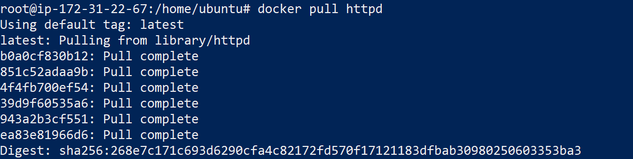

Install Docker Registry

**docker run -d -p 5000:5000 --restart=always --name registry registry:2**

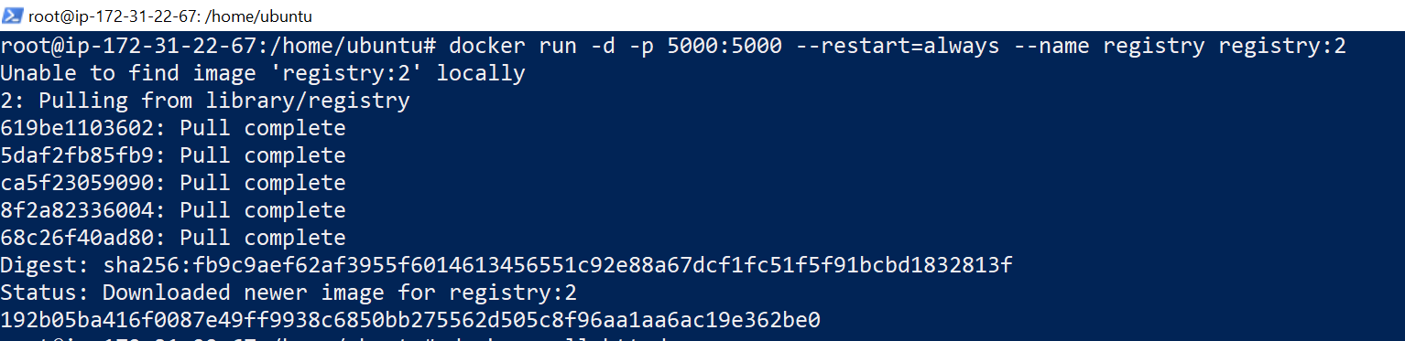

In order to push images to your private registry, you need to configure your Docker client to recognize it as an insecure registry

**echo '{ "insecure-registries": ["localhost:5000"] }' > /etc/docker/daemon.json**

After making changes to **daemon.json**, restart Docker:

**systemctl restart docker**

Tagging local image with the private registry's address

**docker tag your-image localhost:5000/your-image**

Push Images to the Registry

**docker push localhost:5000/your-image**

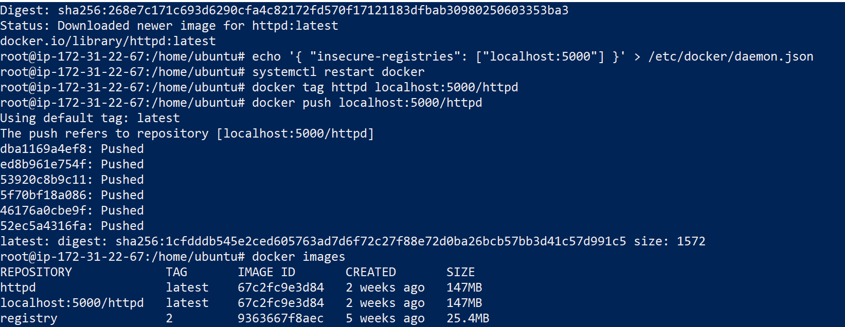

Docker pull localhost:5000/httpd

